Inline css

<!DOCTYPE html>

<html>

    <head>

        <title>Inline CSS</title>

    </head>

    <body>

        <h1 style="color: green;">Heading with green</h1>

        <p style="color: blue;">Paragraph with blue color.</p>

        <h2 style="font-size: 30px;">Font size 30px</h2>

        <h3 style="font-family: fantasy;">Font family fantasy</h3>

    </body>

</html>

Output:



Internal css

<!DOCTYPE html>

<html>

    <head>

        <title>Internal CSS</title>

        <style>

            h1{

                color: violet;

            }

            #p{

                color: pink;

            }

            .h{

                font-family: sans-serif;

                font-size: 50px;

            }

        </style>

    </head>

    <body>

        <h1>Heading with violet</h1>

        <p id="p">Pink Paragraph.</p>

        <h3 class="h">Font family and size 50px</h3>

    </body>

</html>

Output:

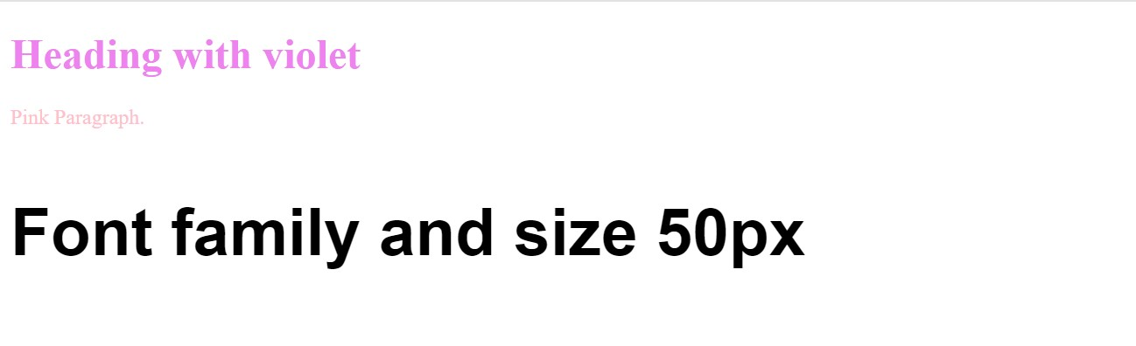

External css

HTML file:

<!DOCTYPE html>

<html>

    <head>

        <title>External CSS</title>

        <link rel="stylesheet" href="External CSS.css">

    </head>

    <body  id="bg">

        <h1 class="heading">Red heading</h1>

        <h3>background-color Yellow</h3>

        <h3 id="fn">Font family Times new roman and white background-color</h3>

        <p>Font size 25px</p>

    </body>

</html>

CSS file:

.heading{

color: red;

}

#bg{

background-color: yellow;

}

#fn{

font-family: 'Times New Roman';

background-color: white;

}

p{

font-size: 25px;

}

Output:

